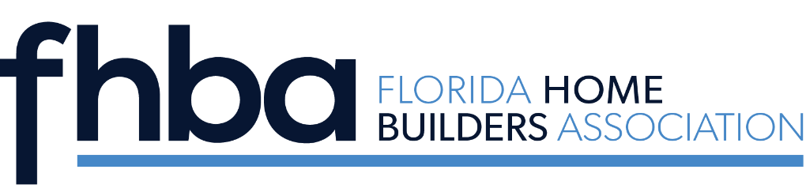
2022 Remodeler of the Year
Candidate Nomination Form

The Stephen D. Gidus Remodeler of the Year Award recognizes a certified industry professional who exhibits best practices, expertise, and exceptional leadership qualities as a Florida remodeler. The Remodeler of the Year is selected annually by past winners, announced at the Summer Conference/SEBC and presented during the Fall Leadership Conference. Application forms are available at www.fhba.com.

Deadline for Entry: Friday, June 1, 2022

Candidate’s Name __________________________________________________________

Local Association Name __________________________________________________________

Firm Name __________________________________________________________

Address __________________________________________________________

City, State, Zip __________________________________________________________

Phone __________________________________________________________

Email __________________________________________________________

Submitted By __________________________________________________________

Signature of Local HBA EO __________________________________________________________

Describe and/or list reasons your candidate should

receive the FHBA Remodeler of the Year award

SEND APPLICATION AND HEADSHOT OF NOMINEE TO KAILIN KOCH AT KKOCH@FHBA.COM.

