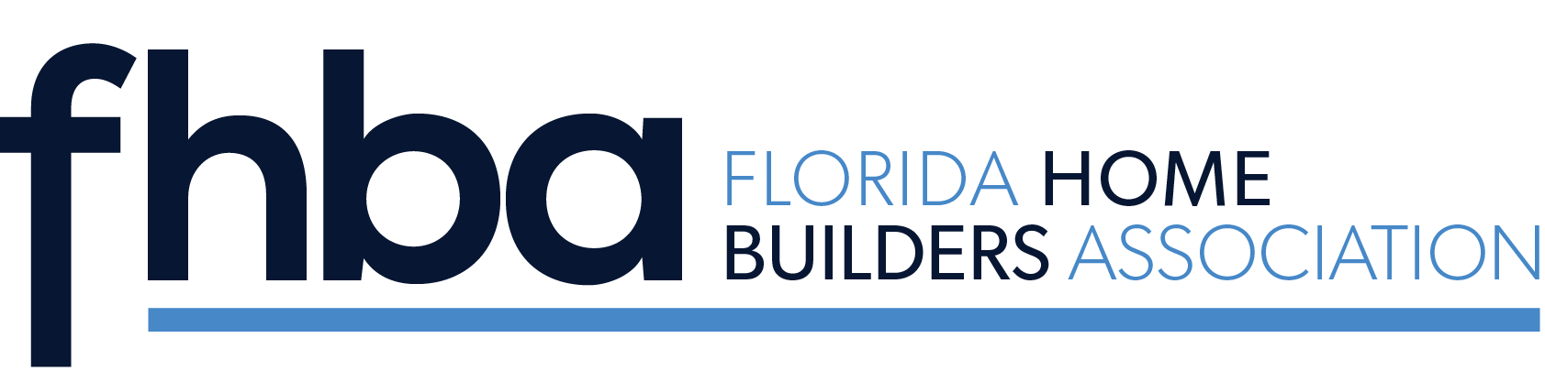

Florida Home Builders Association
Associate of the Year

The Associate of the Year Award encourages expertise in the industry and outstanding leadership qualities. The Associate of the Year is selected annually by the FHBA Past Second Vice Presidents’ Council, announced during the Summer Conference/SEBC and presented during the Fall Leadership Conference. Application forms are available at www.fhba.com.

2023 Wendy Dittmar, Fort Pierce

2022 Mike Keesee, Maitland
2021 Rick Iimbeger, Port Charlotte
2020 Robyn Bonaquist, Naples
2019 Joe Ernst, Sarasota
2018 Sharon Neuhofer, Punta Gorda
2017 Kimberly Mackey, Tampa
2016 Jenny Malone Wiseman, Nokomis
2015 Cindy Hall, Jensen Beach
2014 Bud Swindell, Sarasota
2013 Bill Smock, Sarasota
2012 Arlene Stewart, Gainesville
2011 Mike Rahn, Sarasota
2010 Ann Hagen*
2009 Michelle Delaney, Orlando
2008 Suzanne Graham, Charlotte
2007 Don Zimmer, Orlando
2006 Michael Dannenhauer, Naples
2005 Doug Wenzel, Palm Coast
2004 Dave Carter, Winter Haven
2003 Rob Wilson, Tallahassee
2002 George Barnes, Gainesville
2001 Tom Thornberry, Port Charlotte
2000 Steve Lawson, Naples
1999 George Kavanagh*
1998 Sandy Sims, Niceville
1997 Bonnie Schmidt-Lefoley, Orlando
1996 Rita Williams, Jacksonville
1995 Patti Guthrie, Orlando
1994 Mike Carr, Naples
1993 B.J. Young, Orlando
1992 Jim Bishop, Orlando
1991 John Hall*
1990 Gary/Linda Mortemore, Ft. Lauderdale
1989 Marsha Myers, West Palm Beach
1988 Kay Green, Orlando
1987 Don Lester*
1986 Mark Smith*
1985 Virginia Cotton*
1984 Jack McCombs, Milton
1983 Frank Copare, Orlando
1982 Charley Jay*
1981 Gordon Finch, Tampa
1980 Pete Taylor, Sarasota
1979 Carmel R. Morris, Jacksonville
1978 Phyllis Finney Loconto, Plantation
1977 Al Singer*
1976 Harold Nutter*

*Deceased

