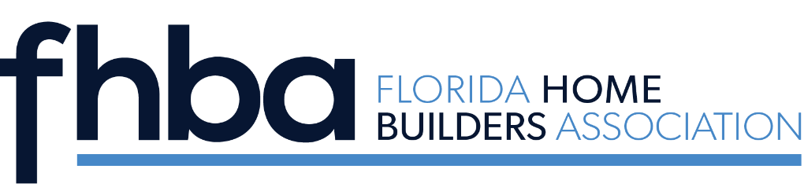
2024 Woman of Distinction Award
Candidate Nomination Form

The award honors a woman who is: active in the Home Builders Association and the building industry; a positive role model for other women in the industry; a leader in their company and at their local HBA; a woman with innovative ideas who is willing to share and mentor with others to make a difference in their industry and/or local HBA; a proven leader outside the HBA that draws positive attention to the HBA; respected inside and outside the HBA; and the personification of positive values.

While this award is open to all new or long term HBA members, it strives to encourage members with unrealized leadership potential to move toward taking a more substantive role at the state level. She is the person who dives in to make things happen, often without realizing that someone has noticed her efforts. She not only has great ideas, but also brings them to fruition. She helps others to make their projects successful and is recognized by her peers.

Award recipients are selected by previous Woman of Distinction Winners from applications received, though there is the option to select a winner based on outstanding observed service. The Winner is announced during the Summer Conference/SEBC and presented at the Fall Leadership Conference. Application forms are available at www.fhba.com.

Deadline for Entry: Friday, June 7, 2024

Candidate’s Name __________________________________________________________

Local Association Name __________________________________________________________

Firm Name __________________________________________________________

Address __________________________________________________________

City, State, Zip __________________________________________________________

Phone __________________________________________________________

Email __________________________________________________________

Submitted By __________________________________________________________

Signature of Local HBA EO __________________________________________________________

On the following page, please describe and/or list reasons your candidate should receive the FHBA Woman of Distinction award

Describe and/or list reasons your candidate should

receive the FHBA Woman of Distinction award

SEND APPLICATION AND HEADSHOT OF NOMINEE TO SHARI HICKEY AT SHICKEY@FHBA.COM.

