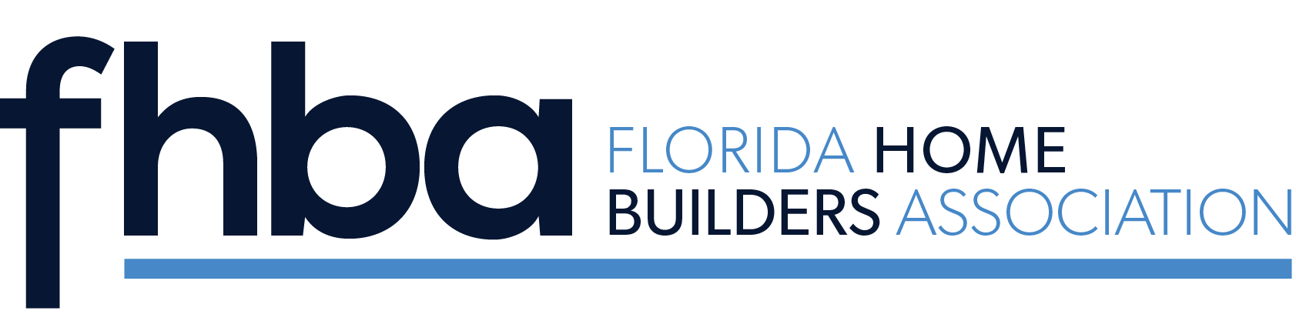

Florida Home Builders Association
Young Building Professional Award

Established in 2019, the FHBA Young Building Professional Award recognizes young building industry professionals who propel their careers; advance in local, state and national associations; advocate for the building industry, engage with peers; and embed themselves as exceptional members of their communities.

The winners of this award are the future of the industry and set new standards for support and growth of the building industry. They are positioned as valuable assets in other’s lives both professionally and personally and are here to move the building industry forward.

2023 Jackie Rowland, Jacksonville
2022 Wes Robbins, Kissimmee
2021 Blaine Flynn, Pensacola
2020 Ryan Benson, Naples
2019 Joe Ernst, Sarasota

*Deceased

